Design a 3-bit Up/Down Counter

**T Flip Flops:**

Step 1:

Step 2:

|  |  |  |  |  |  |
| --- | --- | --- | --- | --- | --- |
| QC | QB | QA | QC* | QB* | QA* |
| 0 | 0 | 0 | 0 | 0 | 1 |
| 0 | 0 | 1 | 0 | 1 | 0 |
| 0 | 1 | 0 | 0 | 1 | 1 |
| 0 | 1 | 1 | 1 | 0 | 0 |
| 1 | 0 | 0 | 1 | 0 | 1 |
| 1 | 0 | 1 | 1 | 1 | 0 |
| 1 | 1 | 0 | 1 | 1 | 1 |
| 1 | 1 | 1 | 0 | 0 | 0 |

Step 3:

|  |  |  |  |  |  |  |  |  |
| --- | --- | --- | --- | --- | --- | --- | --- | --- |
| QC | QB | QA | QC* | QB* | QA* | TC | TB | TA |
| 0 | 0 | 0 | 0 | 0 | 1 | 0 | 0 | 1 |
| 0 | 0 | 1 | 0 | 1 | 0 | 0 | 1 | 1 |
| 0 | 1 | 0 | 0 | 1 | 1 | 0 | 0 | 1 |
| 0 | 1 | 1 | 1 | 0 | 0 | 1 | 1 | 1 |
| 1 | 0 | 0 | 1 | 0 | 1 | 0 | 0 | 1 |
| 1 | 0 | 1 | 1 | 1 | 0 | 0 | 1 | 1 |
| 1 | 1 | 0 | 1 | 1 | 1 | 0 | 0 | 1 |
| 1 | 1 | 1 | 0 | 0 | 0 | 1 | 1 | 1 |

Step 4:

*TA

|  |  |  |  |  |
| --- | --- | --- | --- | --- |
| QBQA  QC | 00 | 01 | 11 | 10 |
| 0 | 1 | 1 | 1 | 1 |
| 1 | 1 | 1 | 1 | 1 |

We have TA = 1

*TB

|  |  |  |  |  |
| --- | --- | --- | --- | --- |
| QBQA  QC | 00 | 01 | 11 | 10 |
| 0 | 0 | 1 | 1 | 0 |
| 1 | 0 | 1 | 1 | 0 |

We have TB = QA = 1

*TC

|  |  |  |  |  |
| --- | --- | --- | --- | --- |
| QBQA  QC | 00 | 01 | 11 | 10 |
| 0 | 0 | 0 | 1 | 0 |
| 1 | 0 | 0 | 1 | 0 |

We have TC = QBQA = 1

Step 5:

Because their inputs are the same (equal to 1), I directly input the value 1.

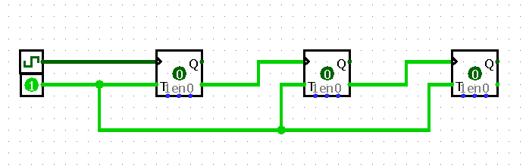

Step 6:

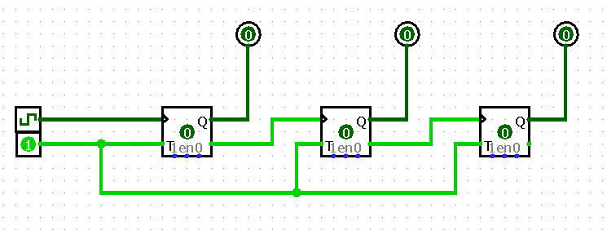

**D Flip Flops:**

Step 1:

Step 2:

|  |  |  |  |  |  |
| --- | --- | --- | --- | --- | --- |
| QC | QB | QA | QC* | QB* | QA* |
| 0 | 0 | 0 | 0 | 0 | 1 |
| 0 | 0 | 1 | 0 | 1 | 0 |
| 0 | 1 | 0 | 0 | 1 | 1 |
| 0 | 1 | 1 | 1 | 0 | 0 |
| 1 | 0 | 0 | 1 | 0 | 1 |
| 1 | 0 | 1 | 1 | 1 | 0 |
| 1 | 1 | 0 | 1 | 1 | 1 |
| 1 | 1 | 1 | 0 | 0 | 0 |

Step 3:

|  |  |  |  |  |  |  |  |  |
| --- | --- | --- | --- | --- | --- | --- | --- | --- |
| QC | QB | QA | QC* | QB* | QA* | DC | DB | DA |
| 0 | 0 | 0 | 0 | 0 | 1 | 0 | 0 | 1 |
| 0 | 0 | 1 | 0 | 1 | 0 | 0 | 1 | 0 |
| 0 | 1 | 0 | 0 | 1 | 1 | 0 | 1 | 1 |
| 0 | 1 | 1 | 1 | 0 | 0 | 1 | 0 | 0 |
| 1 | 0 | 0 | 1 | 0 | 1 | 1 | 0 | 1 |
| 1 | 0 | 1 | 1 | 1 | 0 | 1 | 1 | 0 |
| 1 | 1 | 0 | 1 | 1 | 1 | 1 | 1 | 1 |
| 1 | 1 | 1 | 0 | 0 | 0 | 0 | 0 | 0 |

Step 4:

*DA

|  |  |  |  |  |
| --- | --- | --- | --- | --- |
| QBQA  QC | 00 | 01 | 11 | 10 |
| 0 | 1 | 0 | 0 | 1 |
| 1 | 1 | 0 | 0 | 1 |

We have DA = Not QA

*DB

|  |  |  |  |  |
| --- | --- | --- | --- | --- |
| QBQA  QC | 00 | 01 | 11 | 10 |
| 0 | 0 | 1 | 0 | 1 |
| 1 | 0 | 1 | 0 | 1 |
|  |  |  |  |  |

We have DB = Not QB

*DC

|  |  |  |  |  |
| --- | --- | --- | --- | --- |
| QBQA  QC | 00 | 01 | 11 | 10 |
| 0 | 1 | 0 | 0 | 0 |
| 1 | 1 | 1 | 0 | 1 |

We have DC = Not QC

Step 5:

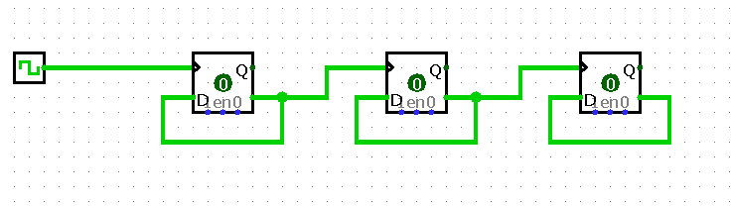

Step 6:

